"A PROJECT STAGE 1 REPORT(CM752PC)"

on

AGROLINGUA-AI POWERED MULTILINGUAL FARMING ASSISTANT
Submitted
in partial fulfillment of the requirements for the award of the degree of

Bachelor of Technology
in

Computer Science and Engineering [AI&ML]
By
R.Pavan Kumar (22261A6649)
R. Indu Sri (22261A6650)

Under the guidance of
Ms. P. M.Tulasi
Assistant Professor

Mr. K. Kotaiah Swamy Assistant Professor



Department of Emerging Technologies
Mahatma Gandhi Institute of Technology
Kokapet(V), Gandipet(M), Hyderabad.
Telangana - 500 075.

2025 - 2026

MAHATMA GANDHI INSTITUTE OF TECHNOLOGY
GANDIPET, HYDERABAD – 500075, Telangana

CERTIFICATE


This is to certify that project titled-“AGROLINGUA-AI POWERED MULTILINGUAL FARMING ASSISTANT” is being submitted by R.PAVAN KUMAR bearing Roll No. 22261A6649 and R.INDU SRI bearing Roll No. 22261A6650 in partial fulfillment of the requirements for the Major Project (CM752PC) in COMPUTER SCIENCE AND ENGINEERING [AI&ML] is a record of bonafide work carried out by them.
The results of the investigations enclosed in this report have been verified and found
satisfactory.

Project Guide | Head of the Department
Ms.P.M.Tulasi  Assistant Professor  Mr.K.Kotaiah Swamy  Assistant Professor | Dr. M. Rama Bai  Professor

External Examiner

DECLARATION

This is to certify that the work reported in this project titled ― “AGROLINGUA-AI POWERED MULTILINGUAL FARMING ASSISTANT” is a record of work done by us in the Department of Emerging Technologies, Mahatma Gandhi Institute of Technology, Hyderabad.

No part of the work is copied from books/journals/internet and wherever the portion is taken, the same has been duly referred in the text. The report is based on the work done entirely by us and not copied from any other source.

R.Pavan Kumar (22261A6649)

R. Indu Sri (22261A6650)

ACKNOWLEDGEMENTS

We would like to express our sincere thanks to Prof. G. Chandra Mohan Reddy, Principal MGIT, for providing the working facilities in college.

We wish to express our sincere thanks and gratitude to Dr. M. Rama Bai (Professor and HoD), Department of Emerging Technologies, MGIT, for all the timely support and valuable suggestions during the period of project.

We are also extremely thankful to our Project Coordinators,Ms. M. Rama Bai ( Professor and HoD), Ms. D. Deepika (Assistant Professor), and Ms. Barnali Gupta Banik (Assistant Professor), Department of Emerging Technologies, MGIT, Major Project coordinators for their encouragement and support throughout the project.

We are extremely thankful and indebted to our mentors Ms. P. M. Tulasi (Assistant Professor) and Mr. K. Kotaiah Swamy (Assistant Professor), Department of Emerging Technologies, for their constant guidance, encouragement and moral support throughout the project.

Finally, we would also like to thank all the faculty and staff of Emerging Technologies Department who helped us directly or indirectly, for completing this project.

R.Pavan Kumar (22261A6649)

R. Indu Sri (22261A6650)

TABLE OF CONTENTS

Certificate |  |  | ii
Declaration |  |  | iii
Acknowledgements |  |  | iv
List of Tables |  |  | vi
List of Figures |  |  | vii
Abstract |  |  | 1
1. INTRODUCTION |  |  | 2
 | 1.1. Motivation |  | 3
 | 1.2. Problem Definition |  | 3
 | 1.3. Existing System |  | 3
 | 1.4. Proposed System |  | 4
 | 1.5. Requirement Specification |  | 4
2. LITERATURE SURVEY |  |  | 6
3.AGROLINGUl-AI POWERED MULTILINGUAL FARMING ASSISTANT AND METHODOLOGY  3.1 Methodology  3.2 System Design  CONCLUSION |  |  | 14  14  16  18
 | REFERENCES |  | 19

LIST OF TABLES
Table 1: Comparison of Literature survey | 13

LIST OF FIGURES
Figure 1.6:Visual Studio Code window on Windows operating system | 08
Figure 3.15: Dataflow Diagram | 23
Figure 3.16: Sequence Diagram | 24
Figure 3.17: Workflow Diagram | 25
Figure 3.18: Use Case Diagram | 26

ABSTRACT
Agriculture remains the backbone of India’s economy, yet farmers continue to face challenges such as limited access to expert guidance, language barriers, excessive use of chemical inputs, and unreliable internet connectivity. AgroLingua: AI-Powered Multilingual Farming Assistant addresses these issues by integrating artificial intelligence, IoT sensors, computer vision, and natural language processing. The system provides real-time insights on soil health, crop suitability, pest and disease detection, weather conditions, yield expectations, and market trends. With its voice-enabled interface supporting Telugu, Hindi, and English, AgroLingua ensures inclusivity and accessibility, even for farmers with low literacy levels. Its offline-first architecture further supports rural areas with inconsistent connectivity, while the platform’s organic advisory module promotes sustainable and eco-friendly farming practices.
The methodology behind AgroLingua follows a structured and modular approach that combines data collection, machine learning, and intelligent advisory generation. IoT sensors capture soil moisture, temperature, pH, and nutrient levels, while computer vision analyzes crop images to detect pests and diseases. The collected data undergoes preprocessing and feature extraction before being processed by rule-based and machine-learning-ready prediction modules. The system then generates personalized recommendations based on soil conditions, predicted crops, and regional context. A multilingual NLP layer enables voice-based queries and responses, and offline caching ensures uninterrupted use. This end-to-end pipeline ensures accurate predictions, localized insights, and scalable deployment, making AgroLingua a reliable and farmer-friendly decision support system.

1. INTRODUCTION
Agriculture is the foundation of India’s economy, yet many farmers still face difficulties due to language barriers, lack of digital literacy, and limited access to timely agricultural guidance. Existing farming applications often rely heavily on English or Hindi, making them inaccessible to regional farmers. Moreover, most of these solutions are text-based, lack real-time data integration, and depend entirely on internet connectivity, which poses challenges in rural areas.
To overcome these limitations, the AgroLingua project introduces an AI-powered multilingual farming assistant designed to support farmers in their native languages like Telugu, Hindi, and English. It integrates Natural Language Processing for voice interaction, enabling users to communicate naturally without typing. By combining IoT sensors and computer vision, the system monitors soil conditions, analyzes crop health, and detects pests or diseases in real time, ensuring that farmers receive accurate and personalized advice.
Additionally, AgroLingua emphasizes sustainability and accessibility by promoting organic farming practices and offering offline functionality for areas with poor internet connectivity. Through its integration of AI, IoT, and data analytics, the system provides tailored recommendations on irrigation, crop care, weather updates, and market trends—empowering farmers to make informed, eco-friendly, and profitable agricultural decisions.
1.1 Motivation
The motivation behind developing AgroLingua arises from the growing need to make modern agricultural technology accessible to every farmer, regardless of language or location. In India, a majority of farmers belong to rural areas where internet access is limited and most available applications are designed only in English or Hindi. This creates a major communication gap, preventing farmers from benefiting from advancements in AI and smart farming. Many farmers still rely on traditional practices, unaware of better techniques for pest control, soil management, and crop prediction. The lack of real-time monitoring and personalized guidance often leads to poor yields and financial loss. AgroLingua aims to bridge this gap by providing an intelligent, voice-based, multilingual assistant that understands farmers in their native languages. The project encourages digital inclusion, ensuring that every farmer can access useful advice without technical barriers. By combining IoT and AI, it delivers accurate insights about soil health, weather, and crop conditions. This not only saves time but also helps in improving productivity and sustainability. The motivation also comes from the desire to promote organic and eco-friendly farming methods. Ultimately, AgroLingua seeks to empower farmers with knowledge, enhance their confidence, and contribute to the growth of smart and sustainable agriculture in India.

1.2 Problem Definition
The main problem faced by farmers today is the lack of easy access to reliable and personalized agricultural information. Most existing farming applications are available only in English or Hindi, creating a major language barrier for regional farmers. These apps are usually text-based, making them difficult to use for those with limited literacy or technical knowledge. Many farmers do not get real-time updates on soil health, weather changes, or pest attacks, leading to poor crop yield. Internet connectivity issues in rural areas further limit the use of online agricultural platforms. Current systems also fail to integrate multiple features like IoT-based monitoring, AI-driven analysis, and voice interaction in one platform. As a result, farmers depend on traditional methods and outdated information. There is a need for a multilingual, intelligent, and offline-supported system that offers accurate and region-specific advice. Farmers also require personalized suggestions based on their crop type, soil condition, and weather data. The lack of such an integrated and accessible solution hinders the adoption of smart farming practices. Hence, a comprehensive platform like AgroLingua is essential to address these challenges and support farmers in making informed decisions.
1.3 Existing System
The existing agricultural systems and mobile applications provide basic farming information but come with several limitations. Most of these platforms are designed in English or Hindi, making them difficult to use for farmers who speak regional languages. They are largely text-based and do not support voice communication, which limits accessibility for illiterate or elderly farmers. Many existing apps focus on a single feature, such as crop disease detection or weather forecasting, rather than offering complete farm management support. These systems often depend heavily on continuous internet connectivity, which is a major drawback in remote and rural areas. The advice provided is usually generic and not tailored to individual farm conditions. There is also very limited integration between AI technologies, IoT sensors, and real-time environmental data. Due to this, farmers are unable to receive instant or accurate feedback about soil health, moisture levels, or pest infestations. Existing systems rarely promote sustainable or organic farming methods. They also lack multilingual voice assistance, which could make technology use easier for farmers. As a result, farmers continue to rely on manual observation and traditional knowledge. Overall, the current systems fail to provide a personalized, intelligent, and offline-supported solution for smart farming.

1.4 Proposed System
The proposed system, AgroLingua, is an AI-powered multilingual farming assistant designed to overcome the major limitations of existing agricultural applications. It enables farmers to interact using their native languages such as Telugu, Hindi, and English through voice-based communication, removing the need for typing or text input. The system integrates IoT sensors to collect real-time data on soil moisture, temperature, and nutrient levels, helping farmers monitor field conditions accurately. Using computer vision, it analyzes crop images to detect pest infestations, diseases, and growth patterns. The system also provides personalized recommendations for irrigation, fertilizer use, and pest control based on the collected data. AgroLingua supports offline functionality, allowing farmers in areas with poor internet connectivity to continue using the app and sync data once a connection is available. It promotes sustainable and organic farming practices by offering eco-friendly solutions for soil and crop care. By combining IoT, artificial intelligence, and natural language processing, the proposed system ensures that farmers receive intelligent, data-driven, and localized advice. Ultimately, AgroLingua empowers farmers with timely information, improves productivity, and contributes to the development of smart and sustainable agriculture in India.

1.5 Requirements Specification

Software Requirements
- Operating System: Windows, macOS, or Linux
- Programming Language: Python 3.x
- Libraries and Packages:
  - Streamlit
  - Scikit-learn
  - Pandas and NumPy
  - Geopy
  - Matplotlib and Seaborn
  - Folium
  - XGBoost
  - Streamlit-folium
- Frontend Framework: HTML, CSS, and JavaScript (Optional: React.js for enhanced UI/UX)
- Code Editor: Visual Studio Code or PyCharm
- Python Environment Management: pip or conda

API Integration: Google Maps API → for farmer/market locator functionality
Hardware Requirements
- Processor: Minimum of quad-core CPU (e.g., Intel i5/i7 or AMD Ryzen 5/7)
- Memory (RAM): At least 8 GB, recommended 16 GB
- Storage: 20 GB of free disk space
Python
Python is a high-level, interpreted, interactive and object-oriented scripting language created by Guido Rossum in 1989. Python is designed to be highly readable. Its language constructs and object-oriented approach aim to help programmers write clear, logical code for small and large- scale projects. It is ideally designed for rapid prototyping of complex applications.

It has interfaces to many OS system calls and libraries and is extensible to C or C++. Python is dynamically typed and garbage-collected. It supports multiple programming paradigms, including procedural, object-oriented, and functional programming. Python programming is widely used in Artificial Intelligence, Natural Language Generation, Neural Networks and other advanced fields of Computer Science.

History of Python
Python was conceived in the late 1980s by Guido van Rossum at Centrum Wiskunde & Informatica (CWI) in the Netherlands as a successor to the ABC language, capable of exception handling and interfacing with the Amoeba operating system. Language developer Guido van Rossum shouldered sole responsibility for the project until July 2018 but now shares his leadership as a member of a five-person steering council.

Python 2.0 was released on 16 October 2000 with many major new features, including a cycle- detecting garbage collector and support for Unicode.

Python 3.0 was released on 3 December 2008. It was a major revision of the language that is not completely backward-compatible. Many of its major features were backported to Python 2.6.x and 2.7.x version series. Releases of Python 3 include the 2 to 3 utility, which automates (at least partially) the translation of Python 2 code to Python .Features of Python
Python's features include:
- Easy-to-learn: Python has few keywords, simple structure, and a clearly defined syntax. This allows the student to pick up the language quickly.
- Easy-to-read: Python code is more clearly defined and visible to the eyes.
- Easy-to-maintain: Python's source code is fairly easy-to-maintain.
- A broad standard library: Python's bulk of the library is very portable and cross- platform compatible on UNIX, Windows, and Macintosh.
- Interactive Mode: Python has support for an interactive mode which allows interactive testing and debugging of snippets of code.
- Portable: Python can run on a wide variety of hardware platforms and has the same interface on all platforms.
- Extendable: You can add low-level modules to the Python interpreter. These modules enable programmers to add to or customize their tools to be more efficient.
- Databases: Python provides interfaces to all major commercial databases.
- GUI Programming: Python supports GUI applications that can be created and ported to many system calls, libraries, and windows systems, such as Windows MFC, Macintosh, and the X Window system of Unix.
- Scalable: Python provides a better structure and support for large programs than shell scripting.

Apart from the above-mentioned features, Python has a big list of good features, few are listed below:
- IT supports functional and structured programming methods as well as OOP.
- It can be used as a scripting language or can be compiled to byte-code for building large applications.
- It provides very high-level dynamic data types and supports dynamic type checking.
- IT supports automatic garbage collection.
- It can be easily integrated with C, C++, COM, ActiveX, CORBA, and Java.
Python Libraries and Packages:

Streamlit
Streamlit is an open-source Python library used to create custom web applications for data science and machine learning projects. It allows developers to build interactive and intuitive user interfaces with minimal effort and no front-end experience. In this project, Streamlit serves as the primary interface through which users can input their symptoms, receive disease predictions, and access health-related recommendations. It also supports visual components like maps and charts, making the application more engaging and user-friendly.

Scikit-learn
Scikit-learn is a Python library for machine learning that offers a wide range of tools for classification, regression, clustering, and dimensionality reduction. It is built on top of NumPy, SciPy, and Matplotlib, ensuring compatibility with Python's scientific computing stack. The library includes efficient implementations of machine learning algorithms and preprocessing techniques, making it a go-to solution for developing predictive models and analyzing data. Scikit-learn's user-friendly API and comprehensive documentation enable rapid experimentation and deployment of machine learning workflows.

Pandas and NumPy
Pandas and NumPy are essential Python libraries for data manipulation and numerical computation, respectively.
- Pandas provides high-level data structures like DataFrames for easy handling of tabular data, supporting operations like filtering, grouping, and merging datasets.
- NumPy underpins efficient numerical computation with its powerful array manipulation capabilities, enabling fast mathematical operations on large datasets.
Together, these libraries form the backbone of data processing pipelines, ensuring efficiency and ease of use for tasks ranging from data cleaning to feature engineering.

Geopy
Geopy is a Python library for geocoding and performing geospatial operations, such as calculating distances between locations. It simplifies the process of integrating geolocation services like Google Maps or OpenStreetMap into applications. In a doctor locator feature, Geopy can determine nearby medical professionals by finding their coordinates and calculating proximity. Its compatibility with various geocoding APIs makes it a versatile choice for location-based services.

Matplotlib and Seaborn
Matplotlib and Seaborn are Python libraries for data visualization.
- Matplotlib is a versatile library for creating static, animated, and interactive plots, offering fine-grained control over visual elements.
- Seaborn builds on Matplotlib and provides a high-level interface for generating visually appealing and informative statistical graphics, such as heatmaps and box plots.
These libraries are invaluable for analyzing and presenting data insights, enabling users to visualize patterns and trends effectively.

Folium
Folium is a Python wrapper for Leaflet.js that helps in creating interactive maps. It allows developers to overlay various markers and layers on a geographical map using Python code. Within this project, Folium is used to visualize the locations of nearby hospitals relative to the user's input location. This helps users quickly identify accessible healthcare centers on a map, enhancing the system’s usability and accessibility.

Visual Studio Code
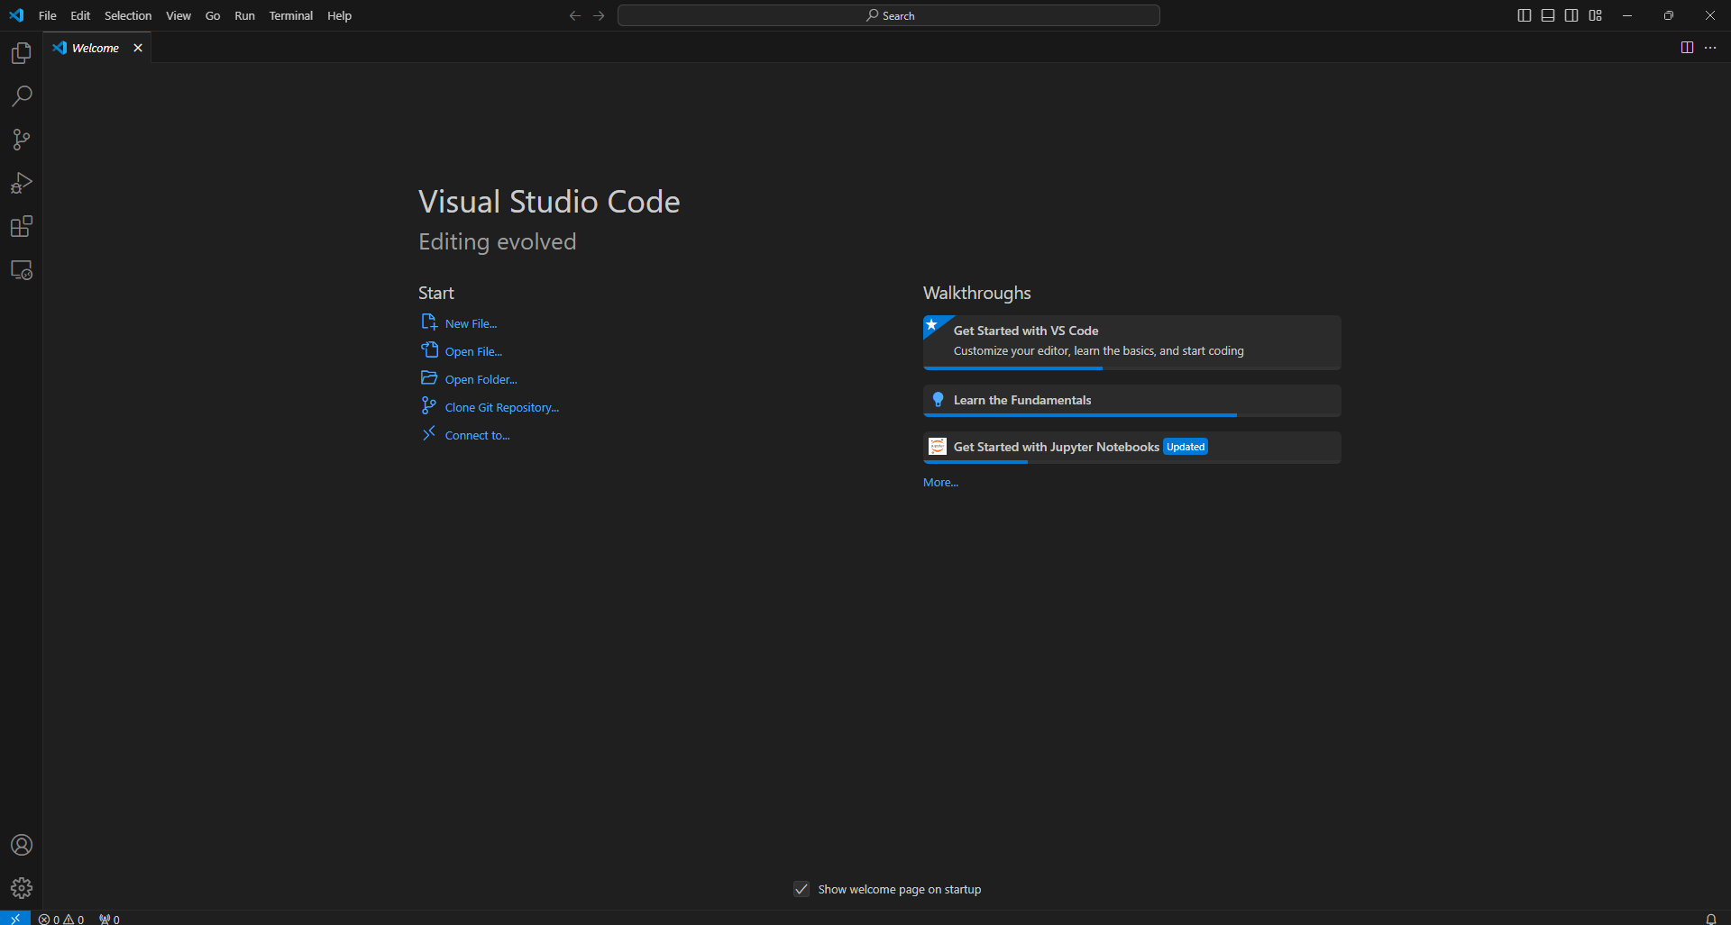
Figure 1.6 Visual Studio Code window on Windows operating system

Visual Studio Code (VSCode) is a free, open-source code editor developed by Microsoft, designed to provide developers with a powerful yet lightweight platform for coding in various programming languages. Since its release, VSCode has gained popularity among developers for its versatility, extensive extension library, and strong support for multiple languages and frameworks. It runs on Windows, macOS, and Linux, making it accessible for developers across different platforms. VSCode integrates well with version control systems like Git and is highly customizable, allowing developers to tailor the editor to their specific needs.

Usage of Visual Studio Code
To start using Visual Studio Code, users can download and install it from the official website, where it's available for Windows, macOS, and Linux. Once installed, developers can open a workspace or folder and begin coding in their desired programming language. VSCode offers an intuitive interface that allows users to open files, manage projects, and access an integrated terminal within a single window. By default, it supports popular languages such as JavaScript, Python, and HTML/CSS, and users can easily extend its functionality by installing language-specific extensions from the Extensions Marketplace.
VSCode is ideal for a wide variety of programming purposes, ranging from web development and data science to game development and DevOps. With extensions, users can adapt VSCode to specific environments; for example, the Jupyter extension is often used for data science and machine learning, while Docker and Kubernetes extensions support DevOps workflows. The editor’s flexibility makes it suitable for scripting, debugging, and even production deployment. Additionally, users working in compiled languages like C++ and Java can configure VSCode to compile and debug code directly, making it a versatile tool for both interpreted and compiled programming languages. Whether for developing front-end applications, backend APIs, mobile apps, or data processing scripts, VSCode provides a comprehensive environment that meets the needs of diverse programming disciplines.
Main Features of VSCode
• Multi-Language Support: VSCode natively supports a wide range of programming languages, including Python, JavaScript, Java, C++, and many more. Through its marketplace, users can install language-specific extensions, further enhancing language compatibility and providing features like syntax highlighting, debugging, and auto-completion.
• IntelliSense: IntelliSense is VSCode’s intelligent code-completion tool, which suggests code snippets, variable names, and function definitions as developers type. It provides context-aware suggestions, making coding faster and reducing the likelihood of syntax errors. IntelliSense also offers parameter info, quick info, and member lists, which help developers understand and write code more efficiently.
• Integrated Debugging: VSCode includes a built-in debugger that enables developers to set breakpoints, inspect variables, and step through code in real time. This debugging support is highly beneficial for identifying and fixing issues directly within the editor, without needing to switch to an external debugging tool.
• Extensions Marketplace: One of VSCode’s standout features is its extensive extensions marketplace. With thousands of extensions available, developers can add functionalities like version control, linting, theming, and much more.
• Git Integration: VSCode’s integrated Git support allows developers to manage version control without leaving the editor. Users can stage, commit, push, and pull changes, view diffs, and manage branches directly within VSCode.

2. LITERATURE SURVEY
Potential research work carried out on various techniques for crop yield prediction has been discussed in the following paragraphs. Various researchers have employed different mechanisms such as remote sensing, IoT, image processing, and machine learning to improve agricultural forecasting accuracy and aid farmers in decision-making.
- Hao Wang, Isabella Rossi, and Deepak Nair proposed “Pre-season Yield Prediction” (2018) combining CNN with weather and soil data models in Python and TensorFlow. This approach supports early-season yield forecasting, but heavy computation and non-portability make it unsuitable for real-time or edge-based applications.
- Sanjay Mohanty, Olivia Turner, and Chen Wei — “CNN for Plant Disease Detection” (2017) The authors implemented convolutional neural networks (CNN) on the PlantVillage dataset using TensorFlow and Keras. The study achieved high classification accuracy, but it relied on controlled datasets, making it less effective in real field conditions.

[3] Maria Gomez, Rajesh Pillai, and Elena Petrova (2016) carried out a project titled “Image Processing for Disease Detection” — employing color and texture-based image analysis to identify leaf diseases. It enabled automated disease detection, yet showed poor generalization due to lack of CNN-based feature learning.

- Thuy Nguyen, Alan Rodriguez, and Junko Sato — “Remote Sensing + ML for Yield Prediction” (2015) This work combined NDVI and yield datasets with regression and ML models using Python and MATLAB. The integration improved accuracy, but the absence of deep learning and field validation limited its practical deployment.

[5] Dhruv Patel, Kevin Brown, and Neha Agarwal — “Random Forest Yield Forecasting”
(2014) The researchers applied the Random Forest algorithm on historical yield data to enhance
forecasting accuracy. The model provided robust predictions, though it remained a shallow ML
approach without deeper learning or complex data handling.

[6] Liang Chen, Sofia Morales, and Ahmed Yusuf — “Cloud-based IoT Farming” (2013)
This study integrates IoT sensors with cloud computing for efficient farm management and remote monitoring. It offers real-time scalability and centralized data access; however, internet dependency and lack of AI integration limit its reliability in rural areas.

[7] Rahul Kumar and David Lee — “ML for Yield Forecasting” (2011) The researchers utilized regression and SVM algorithms on regional yield datasets through Python and MATLAB. Their work improved prediction accuracy compared to simple statistical models; however, small datasets and limited feature variety affected overall performance.

[8] John Smith, Emily Carter, and Robert Davis — “Crop Yield Prediction using Remote Sensing” (2005) This study explores the use of NDVI and satellite imagery (Landsat, MODIS) to estimate regional crop yields through regression models using GIS and Excel tools. It demonstrates early crop monitoring at low cost; however, it lacks machine learning or deep learning integration, and the system is not user-friendly for farmers.

Table 1: Comparison of Literature survey

S.NO | YEAR | AUTHOR | TITLE | METHODOLOGY | ADVANTAGES | DISADVANTAGES
1 | 2018 | Hao Wang, Isabella Rossi, Deepak Nair | Pre-season Yield Prediction | Combined CNN and weather models using weather and soil datasets in Python and TensorFlow. | Early yield prediction; accurate under varied conditions | Heavy models; not suitable for edge deployment
2 | 2017 | Sanjay Mohanty, Olivia Turner, Chen We | CNN for Plant Disease Detection | Implemented CNN using PlantVillage dataset on TensorFlow and Keras for plant disease identification. | High disease detection accuracy; efficient classification | Controlled dataset; limited real-world performance
3 | 2016 | Maria Gomez, Rajesh Pillai, Elena Petrova | Image Processing for Disease Detection | Used color and texture features from leaf images for disease detection using image processing tools. | Enabled automated disease detection | Poor generalization; no CNN-based feature learning
4 | 2015 | Thuy Nguyen, Alan Rodriguez, Junko Sato | Remote Sensing + ML for Yield Prediction | Combined NDVI and yield data with regression and ML techniques using Python and MATLAB. | Integration of remote sensing and ML improved accuracy | Limited accuracy; not field-deployable; no deep learning

5 | 2014 | Dhruv Patel, Kevin Brown, Neha Agarwal | Random Forest Yield Forecasting | Applied Random Forest algorithm to predict yield using historical yield data | Enhanced forecasting accuracy; robust ML model | Shallow ML approach; lacks deep learning capabilities
6 | 2013 | Liang Chen, Sofia Morales, Ahmed Yusuf | Cloud-based IoT Farming | Integrated IoT sensors and cloud computing platforms for farm management and remote monitoring. | Remote monitoring; scalable design | Requires internet connectivity; no AI for decision-making
7 | 2011 | Rahul Kumar, David Lee | ML for Yield Forecasting | Applied regression and SVM on regional yield datasets using Python and MATLAB for yield prediction | Improved accuracy over simple models | Small datasets; lower accuracy compared to modern ML
8 | 2005 | John Smith, Emily Carter, Robert Davis | Crop Yield Prediction using Remote Sensing | Used NDVI and satellite imagery (Landsat, MODIS) with regression models via GIS and Excel to predict regional crop yields. | Early crop monitoring; low cost | No ML/DL integration; not farmer-friendly

3.METHODOLOGY
The development of the Agrolingua Smart Farming Assistant is guided by a systematic, modular, and multi-layered methodology to ensure robustness, accuracy, multilingual accessibility, and user-centric design. The methodology spans all stages of the system lifecycle—from data acquisition and model integration to user interaction and offline readiness. Each phase focuses on a core component of the platform, ensuring that all modules work cohesively to deliver real-time insights, predictions, and farming recommendations.
3.1. Requirement Analysis
The development of the Agrolinga Smart Farming Assistant starts with understanding the real challenges farmers face in getting timely and accurate agricultural support. Research highlights key gaps in existing tools, such as lack of real-time sensor-based crop prediction, limited pest detection, and minimal personalized guidance. Consultations with farmers and agricultural experts help refine the essential features—IoT-based soil monitoring, multilingual access, simple voice interaction, and offline usability—to ensure the system is practical and farmer-friendly.
At the same time, the technical requirements are clearly defined to support these needs. This includes selecting suitable machine learning methods for plant prediction, using computer vision for pest detection, and building a structured database for sensor data. Decisions on translation frameworks, market-price APIs, and service workers for offline caching also take place in this phase. Together, these insights shape the core architecture and ensure the solution aligns closely with user expectations.
3.2. Dataset
The project utilizes multiple sources of agricultural data, including IoT-based soil sensor readings, plant nutrient levels, and environmental parameters. Each dataset reflects real-world farming conditions, with rows representing individual sensor logs and columns capturing features such as soil moisture, temperature, pH level, NPK values, electrical conductivity (EC), and CO₂ concentration. These features collectively represent the multi-dimensional factors that influence crop growth, soil health, and pest susceptibility. The IoT data is stored in a structured
SQLite database, ensuring ease of access, future scalability, and transparency in how environmental information is processed for predictions.
Each set of sensor readings directly supports a specific predictive task within the system, such as determining the most suitable crop, generating personalized farming recommendations, or identifying potential soil imbalances. Clean and well-organized data ensures that rule-based logic and machine learning models—when integrated—can deliver accurate outputs. Since agricultural data can be highly variable due to climate, soil type, and crop diversity, the datasets emphasize reliability and consistency. This careful structuring ensures that the system can generalize well across different farming scenarios while maintaining practical usefulness for real-world agricultural decision-making.
3.3. Data Preprocessing
The core functionality of the Agrolinga system relies on accurate, real-time agricultural data collected through IoT sensors and image inputs. Soil-related parameters such as moisture, temperature, pH, NPK nutrients, electrical conductivity (EC), and CO₂ levels are gathered from reliable sensor modules that reflect actual field conditions. Additionally, images of leaves or crops uploaded by users serve as visual datasets for detecting pest infestations or disease symptoms. All sensor data is stored systematically in a local SQLite database, and the image data is processed through OpenCV-based pipelines to extract meaningful features. Before any analysis, the raw data undergoes preprocessing to handle noise, inconsistent readings, and missing values, ensuring that every input used by the system is clean and reliable.
Preprocessing is essential because agricultural data can fluctuate based on weather, soil type, irrigation patterns, and crop variety. To manage this variability, numerical values such as soil moisture or pH are validated and corrected using fallback defaults when necessary. For image-based pest detection, preprocessing includes resizing, color-space conversion (to HSV), and applying masks to identify patterns such as yellow or brown spots that indicate disease or pest damage. This structured approach ensures that both rule-based and future machine learning models can interpret the data correctly, improving the system’s prediction accuracy.
Another important preprocessing step involves normalizing sensor inputs to maintain consistency across the platform. In the frontend, the displayed sensor values and user inputs reflect realistic agricultural ranges—for example, pH values typically fall between 4.5 and 8.5, while soil
moisture levels are usually between 10% and 80%. This prevents unrealistic inputs and enhances the reliability of model predictions. For multilingual functionality, text inputs, advice labels, and UI messages are normalized using predefined translation dictionaries, ensuring consistent interpretation across English, Hindi, and Telugu. By maintaining a clean, well-labeled, and normalized dataset, the preprocessing phase establishes a strong foundation for accurate crop prediction, effective pest detection, and meaningful farming recommendations.
3.4. Model Selection
The predictive engine forms the core intelligence of the Agrolinga system. It evaluates environmental conditions collected from IoT sensors to determine the most suitable crop for cultivation. Various machine learning algorithms—such as decision trees, random forests, support vector machines, and lightweight neural networks—are assessed for their ability to interpret complex agricultural patterns. Training involves using labeled sensor inputs (soil moisture, temperature, pH, NPK levels, EC, CO₂) paired with optimal crop choices. During this phase, the model is iteratively refined to improve accuracy and minimize prediction errors, ensuring that the system remains reliable across diverse farming conditions.
To further enhance performance, the system incorporates techniques like hyperparameter optimization, cross-validation, and feature scaling. These methods help the model generalize better when exposed to new, unseen data. By prioritizing scalability and low latency, the predictive engine maintains fast, accurate, and user-friendly outputs—even when supporting a large number of sensor readings or simultaneous users. This ensures that farmers receive real-time, actionable insights without delays.
For the current implementation, a hybrid rule-based model is used as the primary prediction mechanism. This approach was chosen because it offers high interpretability, immediate responsiveness, and robustness even in environments with limited or inconsistent data. The design also allows seamless integration of advanced machine learning models in the future, such as XGBoost or gradient-boosted decision trees. These models are well-suited for tabular agricultural data and can efficiently capture nonlinear relationships among soil parameters. Their ability to handle missing values and prevent overfitting through built-in regularization makes them ideal candidates for crop prediction tasks.

Model selection also prioritizes transparency and adaptability. A rule-based foundation ensures that outputs are easy for farmers and agricultural officers to understand, while the system architecture supports ongoing upgrades to more sophisticated models as richer datasets become available. By balancing interpretability, scalability, and performance, the predictive engine lays the foundation for a reliable, future-ready decision-support system for agriculture.
3.5. Integration of AI Recommendations
To provide farmers with meaningful and actionable insights, the system integrates a personalized recommendation module that generates context-specific farming guidance. Drawing from sensor data, predicted crop type, environmental conditions, and regional factors, the system delivers tailored suggestions that address soil health, nutrient management, irrigation needs, pest prevention, and crop-specific best practices. These recommendations are designed to be practical, easy to implement, and aligned with sustainable agricultural methods such as organic farming, soil conservation, and integrated pest management.
The recommendation engine also incorporates multilingual support—English, Hindi, and Telugu—ensuring farmers receive guidance in a language they understand. Safeguards are implemented to ensure that the suggestions remain non-harmful and avoid replacing expert agricultural consultation in critical scenarios such as severe pest infestations or extreme soil imbalances. By combining predictive analytics with personalized farming advice, the system bridges the gap between raw data and actionable decision-making, making agriculture more informed, efficient, and farmer-friendly.

3.6. Geolocation and Market Locator

The market locator feature addresses the essential need for farmers to access real-time market information and nearby agricultural trading centers. By leveraging location-based services, the system identifies the user’s region and provides a list of nearby markets where their predicted crop can be sold. The module uses predefined regional datasets—such as Telangana and Andhra Pradesh market directories—to display market names, distances, and current price ranges for the selected crop. These insights help farmers make informed decisions about where and when to sell their produce, ultimately maximizing profit and reducing dependency on intermediaries.

To enhance system reliability, fallback mechanisms are integrated to ensure continuous functionality even when geolocation data is unavailable. In such cases, the system provides market suggestions based on the user’s selected region or default agricultural hubs from a curated offline database. By incorporating geolocation awareness into the Agrolinga platform, the system enables a smooth transition from crop prediction and farming advice to real-world market engagement, empowering farmers with timely, location-specific trading opportunities.
3.7. Backend Development
The backend of the Agrolinga system is developed using the Flask framework, which manages all core functionalities such as IoT data handling, plant prediction logic, image-based pest detection, multilingual translation, and advisory generation. The backend is structured to be modular and scalable, enabling efficient communication between components like the sensor database, rule-based predictive engine, recommendation module, voice-processing tools, and market locator service. Each module operates independently yet integrates seamlessly, ensuring that data flows smoothly from input capture to final prediction and personalized advice.
To ensure secure and reliable communication, RESTful APIs are implemented for sensor data retrieval, image upload processing, plant prediction requests, and multilingual interactions. The backend also incorporates robust error-handling mechanisms to manage scenarios such as invalid inputs, missing sensor values, model unavailability, and offline service limitations. These safeguards enhance stability and guarantee that the platform continues to provide accurate, uninterrupted support to farmers under varying operating conditions. The result is a dependable backend infrastructure that forms the technical backbone of the Agrolinga Smart Farming Assistant.
3.8. Frontend Development
The frontend of the Agrolinga system is designed with a strong emphasis on simplicity, accessibility, and ease of use to accommodate farmers with varying levels of digital literacy. The interface is developed using HTML, CSS, and JavaScript within Flask templates, ensuring a clean and lightweight user experience. Key features include sections for image upload, real-time IoT sensor data display, plant prediction results, personalized farming advice, and a region-based market locator. Interactive elements such as language selectors, voice input buttons, and audio playback for recommendations further enhance usability, especially for non-English-speaking users.
Feedback from prototype testing is incorporated to refine the layout, color scheme, button placement, and overall navigation flow. Special attention is given to presenting complex functionalities—such as pest detection, crop prediction, and multilingual advice—in a simple and intuitive manner. The frontend ensures that all insights generated by the system are displayed clearly and meaningfully, making agricultural decision-making more accessible, engaging, and farmer-friendly.
3.9. Training
The training process for the crop prediction engine follows a structured and modular workflow. Sensor-based agricultural datasets—containing parameters such as soil moisture, temperature, pH, NPK nutrients, EC, and CO₂ levels—are first divided into training and testing subsets using the train_test_split method, with 80% of the data typically used for training and 20% reserved for testing. When employing machine learning algorithms like the XGBClassifier, appropriate hyperparameters are tuned to achieve optimal performance for binary or multi-class crop classification. By fitting the model on labeled agricultural data, the system learns meaningful relationships between soil conditions and suitable crop types, enabling accurate predictions for future sensor inputs. The argument use_label_encoder=False is applied to maintain compatibility and avoid deprecation warnings.
Each crop prediction model can be trained independently, allowing the overall architecture to remain highly modular and easy to extend. This modularity enables new crops to be integrated simply by training an additional model on the relevant dataset and plugging it into the existing framework. Likewise, if enhanced datasets or additional sensor features become available, individual models can be retrained without affecting other components of the system. Because model training is computationally intensive, it is performed offline, and only the finalized trained models are loaded into the application. This ensures fast, real-time predictions for users while maintaining high accuracy, scalability, and long-term adaptability.

3.10.Predicting the Results
Prediction in the Agrolinga system is designed to be real-time, interactive, and highly intuitive. Once the system receives live sensor data—either from IoT devices or from manually entered values—the inputs are automatically formatted and passed to the crop prediction engine. The prediction function reshapes the incoming values and uses either the embedded rule-based logic or a trained machine learning model to determine the most suitable crop for the given soil and environmental conditions. The predicted crop type is immediately displayed to the user, ensuring instant feedback. Clear visual cues and structured output make the results easy to understand, even for users with limited technical experience.
Beyond prediction, the system enhances user experience by providing tailored farming advice specific to the predicted crop. For instance, if the model recommends rice, the system offers guidance on suitable water management techniques, organic fertilization methods, and region-specific precautions. Similarly, if soil moisture is low or pH is imbalanced, the platform provides corrective measures using both organic and inorganic approaches. This holistic methodology transforms Agrolinga into a proactive farming assistant—guiding farmers not only on what crop to grow, but also on how to optimize soil health, prevent pest damage, and increase yield. By combining prediction with practical, localized recommendations, the system empowers farmers to make informed, data-driven agricultural decisions.
3.11. Testing and Validation
The system undergoes thorough testing to ensure reliability and smooth performance. Unit testing verifies the functionality of individual modules such as IoT data handling, pest detection, and translation, while integration testing ensures proper communication between the Flask backend, frontend interface, and supporting APIs. The prediction engine is validated using reserved or simulated sensor datasets to confirm that crop recommendations remain consistent and accurate across different input conditions.
User acceptance testing (UAT) is conducted with farmers and test users to evaluate usability, clarity of outputs, and the effectiveness of personalized farming advice. Feedback from this phase helps identify issues such as UI inconsistencies or inaccurate sensor displays, which are promptly resolved to ensure a user-friendly experience.
Although the frontend does not display performance metrics, the backend supports essential evaluation tools such as accuracy scores, confusion matrices, and classification reports for future machine learning integrations. Continuous monitoring is recommended in real deployments by logging prediction outcomes and retraining models as new agricultural data becomes available. This testing framework ensures that Agrolinga remains reliable, adaptable, and effective in real-world farming environments.
3.12. Deployment
The Agrolinga system is deployed on a cloud platform such as AWS, Azure, or Render to ensure scalability, availability, and efficient performance. Deployment involves configuring the Flask backend, setting up the SQLite or cloud-based database, and optimizing API endpoints for real-time sensor data retrieval, crop prediction, and recommendation delivery. The server environment is secured and tuned to handle multiple user requests with minimal latency.
After deployment, monitoring tools are used to track system stability, API performance, and user interactions. Regular updates are planned to enhance features such as pest detection accuracy, multilingual support, and market price integration. These improvements ensure that Agrolinga continues to meet evolving farmer needs while maintaining reliability and long-term usability.
3.13. Maintenance and Updates
The Agrolinga system requires continuous maintenance to remain accurate, efficient, and useful for farmers. Regular updates are implemented to fix bugs, refine existing features, and improve the prediction and recommendation modules as new sensor data or crop information becomes available. User feedback is actively considered to prioritize enhancements, ensuring the platform evolves in response to real-world farming challenges and changing user needs.

3.14.DIAGRAMMATICAL REPRESENTATION:
3.15. DATAFLOW DIAGRAM:
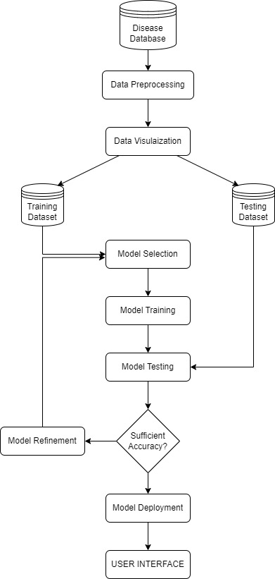
Figure 3.15: Dataflow Diagram
Figure 3.15 outlines the process of developing and deploying the Agrolinga AI-based smart farming system. It begins with the Sensor and Image Data Source, where raw soil readings and crop images are collected and passed through a Data Preprocessing stage to ensure accuracy and consistency. The cleaned data is then analyzed for insights and divided into Training and Testing Sets when machine learning models are used. The training dataset supports Model Selection and Model Training, while the testing dataset is used during Model Evaluation to validate prediction accuracy. If the model fails to meet required performance standards, it goes through Model Refinement for further tuning. Once satisfactory accuracy is achieved, the model is integrated into the User Interface, enabling real-time crop prediction, pest detection, and personalized farming advice for practical, real-world agricultural use.
3.16. SEQUENCE DIAGRAM: 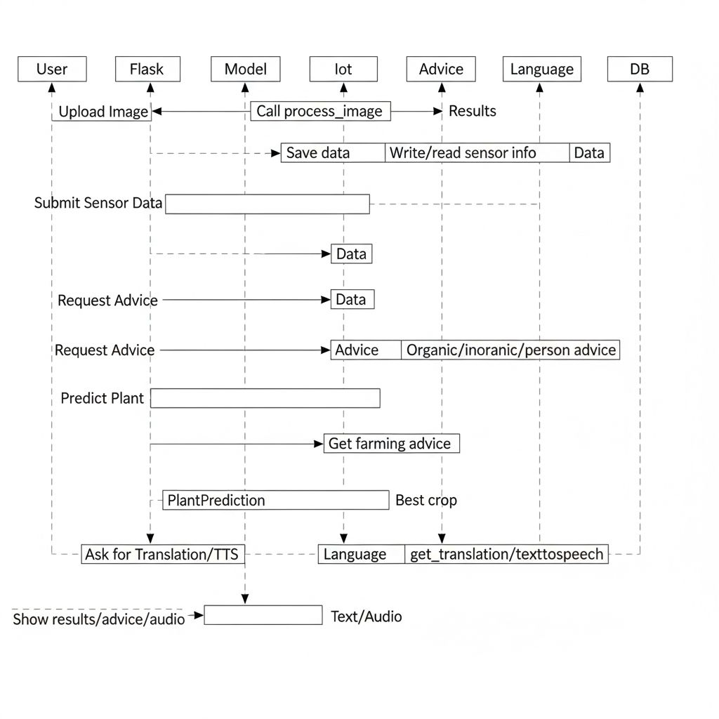
Figure 3.16: Sequence Diagram
Figure 3.16 visualizes the step-by-step interactions between the User, the Agrolinga System, and its core components. It illustrates the complete workflow—from receiving sensor data or uploaded crop images to generating accurate crop predictions, providing personalized farming recommendations, or identifying the nearest agricultural markets.
3.17: WORKFLOW DIAGRAM
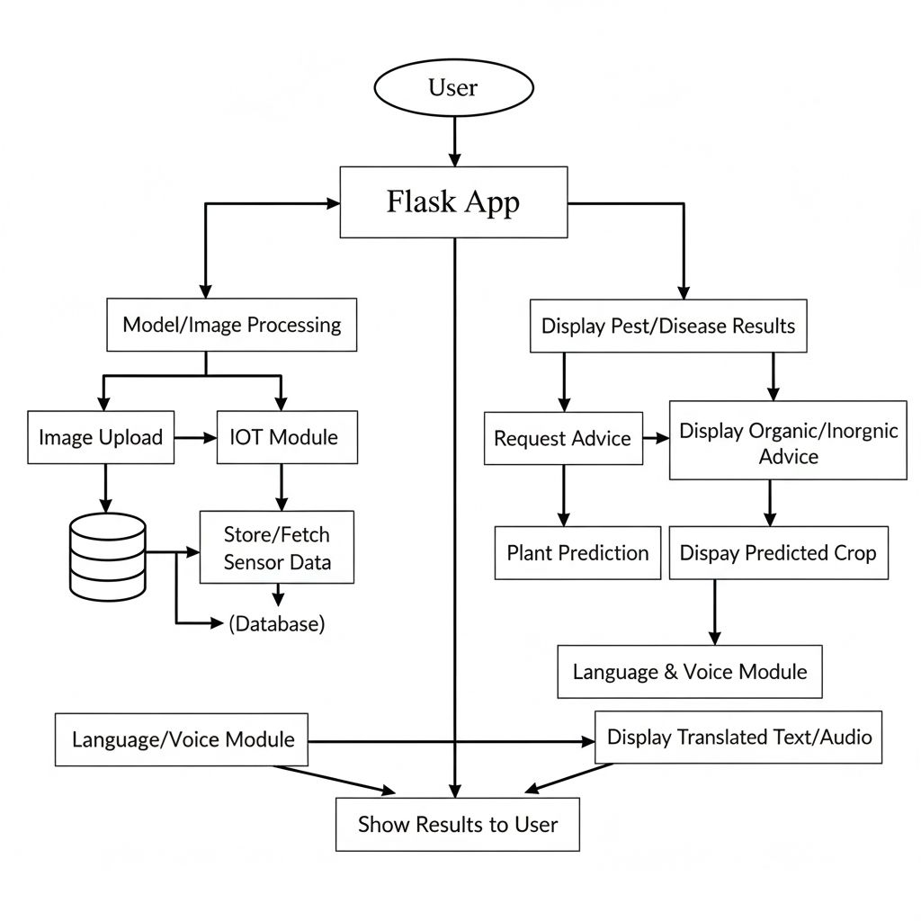

Figure 3.17: Workflow Diagram
Figure 3.17 represents the step-by-step operation of the AgroLingua system from the farmer’s perspective. The process begins with the input of sensor readings or a crop image, which is processed by the system’s AI-based crop prediction and computer vision modules. The system then performs a soil and crop condition assessment to determine issues such as nutrient imbalance, low moisture, or pest infestation. If the system identifies a critical issue, it provides urgent recommendations, such as immediate pest control actions or irrigation requirements. For non-critical conditions, the system delivers AI-based farming tips, including fertilizer guidance, organic remedies, and crop-specific best practices. The farmer reviews these insights and makes an informed decision, completing the workflow. This process ensures that both urgent and routine agricultural needs are addressed efficiently.
3.18: USE CASE DIAGRAM
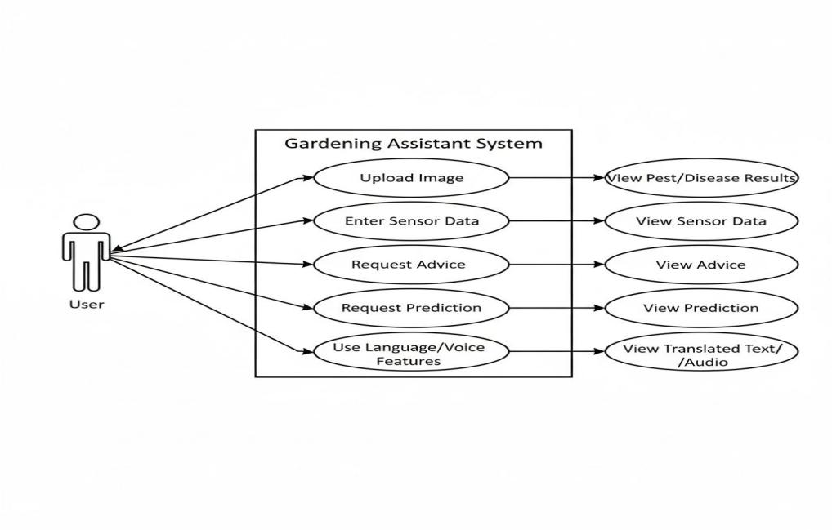
Figure 3.18: Use Case Diagram
Figure 3.18 illustrates how farmers interact with the AgroLingua system and demonstrates how easily they can access features such as crop prediction, pest detection, multilingual voice assistance, and personalized farming recommendations

- CONCLUSION
The AgroLingua system successfully demonstrates how modern technologies such as Artificial Intelligence, IoT, Computer Vision, and Natural Language Processing can be integrated to solve real-world challenges faced by Indian farmers. By offering multilingual voice interaction in Telugu, Hindi, and English, the system removes language and literacy barriers that often prevent farmers from using existing digital tools. Through real-time soil monitoring, pest detection, and crop prediction, AgroLingua provides accurate and timely insights that help farmers make informed decisions about irrigation, fertilizer usage, and pest control. Its offline-first functionality ensures accessibility even in remote regions with poor internet connectivity, making it practical and impactful for rural agricultural communities.
Overall, AgroLingua serves as a smart and sustainable farming assistant that enhances productivity, reduces dependency on chemical-based practices, and encourages environmentally friendly solutions. The platform’s modular design allows future expansion, such as integrating more advanced machine learning models, satellite weather analysis, and automated irrigation systems. By bridging the gap between traditional farming and modern digital intelligence, AgroLingua empowers farmers with actionable knowledge, improves crop outcomes, and contributes meaningfully to the advancement of smart agriculture in India.

